<<NOTE: Check class notes also>>

Dijkstra’s algorithm
Dijkstra’s algorithm (or Dijkstra’s shortest path algorithm) is used to find the minimum distance from a starting node (source) to every other node in a weighted graph with non-negative edge weights.
We can think of it as a method of gradually exploring paths from the source node and continuously updating the shortest known distance to each node until the optimal solution is found. This process ensures that we always move toward the most efficient route possible.
For example, if we use Dijkstra algorithm in a road network, the nodes represent cities, and the edges represent roads with distances as weights. The algorithm helps us find the shortest driving route between two cities.

How Dijkstra algorithm works
The working of Dijkstra’s algorithm follows a greedy approach—it always picks the node with the smallest known distance and expands from there.
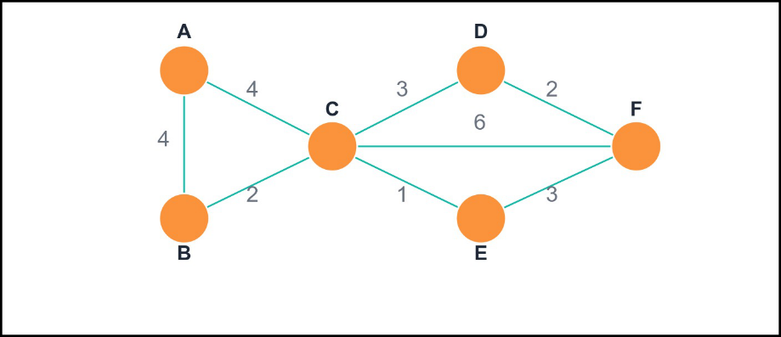

This is a weighted graph with nodes A, B, C, D, E, and F, joined by edges that carry non-negative weights. We’ll use Dijkstra algorithm to find the shortest route from A (source node) to every other node in the graph.

Step 1: Initialization
First, the initial distances from the source node (A) to all other nodes in the graph are established. The distance from the source to itself is set to 0, while the distances to all remaining nodes (B, C, D, E, F) are initialized to infinity (∞), indicating that they are not yet reachable. The algorithm then begins its exploration from the source node.
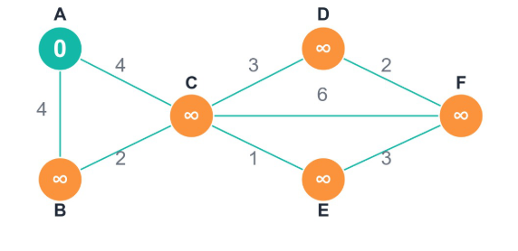

Step 2: Processing Node A
From node A, the algorithm examines all directly connected neighbors. Node A has edges to nodes B and C, each with a weight of 4. The tentative distances to these nodes are calculated as follows:
- Distance to B = 0 + 4 = 4
- Distance to C = 0 + 4 = 4
Since these distances are smaller than their previous values (∞), they are updated. The remaining nodes (D, E, F) retain their initial distances of ∞.
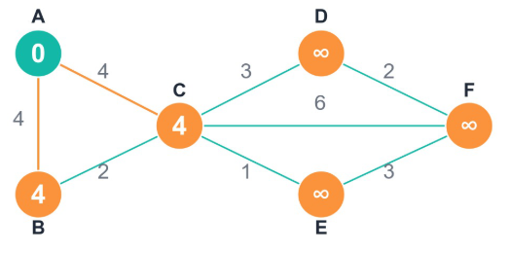

Step 3: Processing Node B
Next, the algorithm selects the unvisited node with the smallest known distance. Both B and C have a distance of 4, so the algorithm may choose either; suppose it selects B.
From node B, the algorithm inspects its unvisited neighbors. B connects to C with an edge of weight 2. The tentative distance to C through B is 4 + 2 = 6.
Since 6 is greater than C’s current distance (4), no update is made. The algorithm then proceeds to the next unvisited node with the smallest distance, which is C.
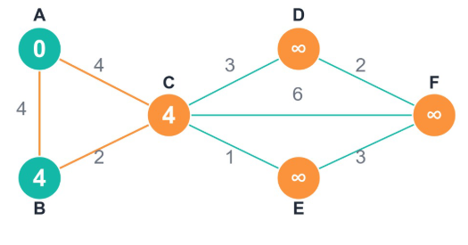

Step 4: Processing Node C
From node C (distance 4), the algorithm examines its unvisited neighbors: D, E, and F. The tentative distances are calculated as:
- Distance to D = 4 + 3 = 7
- Distance to E = 4 + 1 = 5
- Distance to F = 4 + 6 = 10
All of these values are smaller than the current distances (∞), so they are updated accordingly.

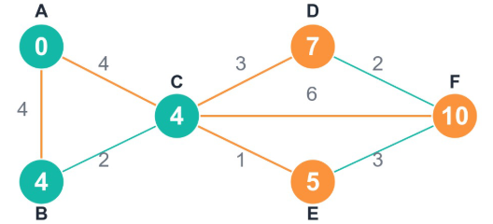

Step 5: Processing Node E
The next unvisited node having the smallest distance is E (distance 5). From E, the algorithm checks its unvisited neighbours D and F:
- Distance to D via E = 5 + 3 = 8 → not smaller than the current D (7), so no update.
- Distance to F via E = 5 + 3 = 8 → smaller than the current F (10), so F is updated to 8.
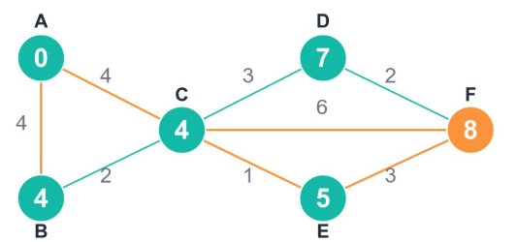

Step 6: Processing Node D
The next node with the smallest distance is D (distance 7). Its only unvisited neighbour is F, with an edge weight of 2. The distance to F via D is 7 + 2 = 9. Since 9 is not smaller than the current F (8), no update is made.
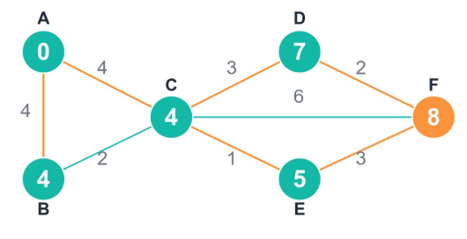
Once all nodes have been visited, the algorithm terminates. The final shortest distances from the source node (A) to all other nodes are:
- A = 0
- B = 4
- C = 4
- D = 7
- E = 5
- F = 8
These distances represent the shortest path tree originating from node A, showing the minimum cost to reach every other node in the graph.
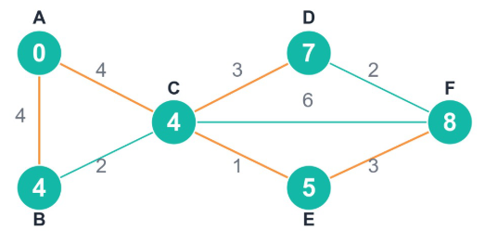

- Key takeaways:
- Dijkstra’s algorithm calculates the shortest path from a source node to all other nodes in weighted graphs with non-negative edges
- It uses a greedy approach, always selecting the unvisited node with the smallest known distance
- With a min-heap implementation, Dijkstra’s algorithm achieves O((V + E) log V) time complexity, making it highly efficient for most practical applications
- The algorithm powers technologies we use daily—from GPS navigation to network routing protocols

